1. **Agenda**:
   1. We will see what happens when a Topic has multiple consumers/subscribers.
2. We already saw that if a queue has multiple consumers, only one of them will receive the msg.  
   But in case of Topic, all the consumers/subscribers, will get the msg.
3. Let’s create two subscribers for the Topic Demo-Topic.
4. 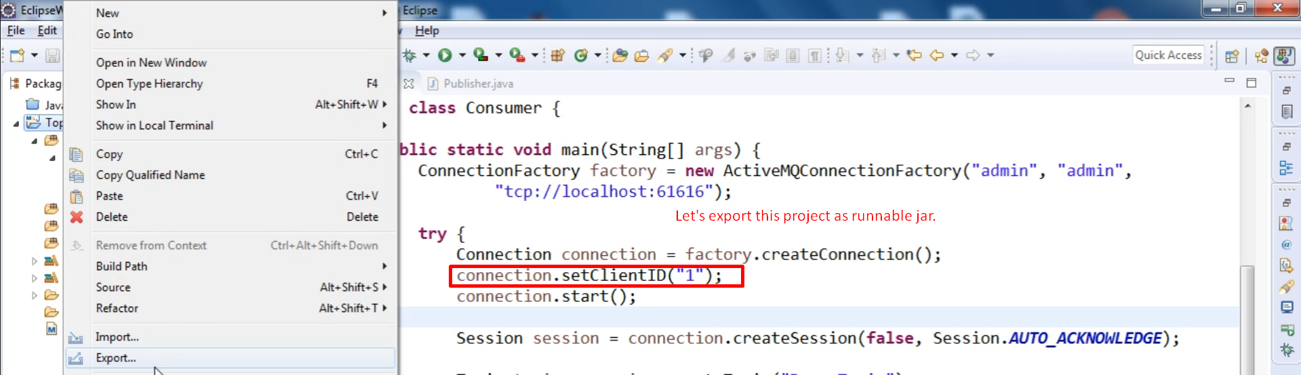  
   Graphical user interface, text, application, email

   Description automatically generated  
   Graphical user interface, application

   Description automatically generated  
     
   **Let’s create one more jar for second subscriber.**  
   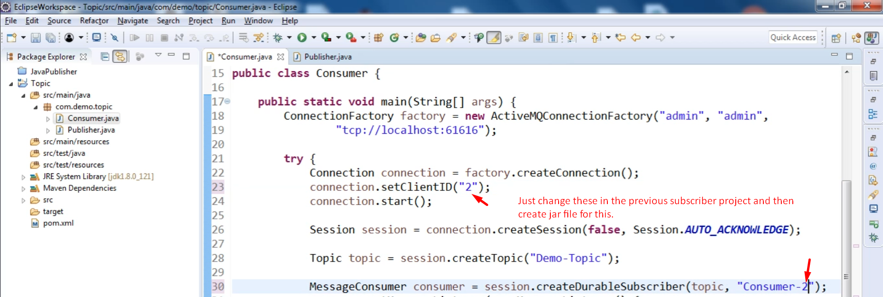  
   Graphical user interface, application

   Description automatically generated
5. Graphical user interface

   Description automatically generated
6. Running both the subscribers/consumers  
   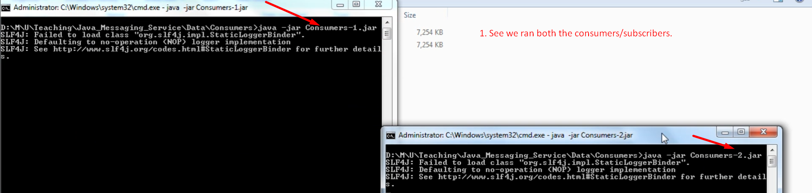
7. Graphical user interface, application

   Description automatically generated
8. Publishing a msg to the Queue.  
   Graphical user interface, text, application

   Description automatically generated
9. See both the consumers received the msg  
   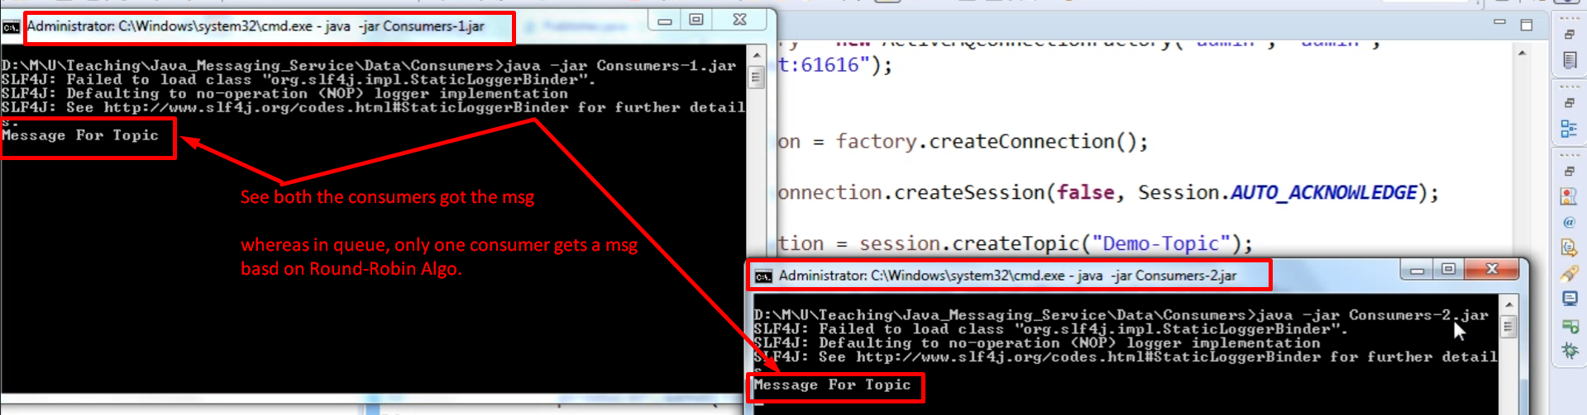
10. This is how a Topic works in Apache ActiveMQ.